**CHAPTER – 1**

**1 INTRODUCTION**

**1.1 OVERVIEW**

Renewable energy generation is very important thing in every country. Because With increasing concern of global warming and the depletion of fossil fuel reserves, many are looking at sustainable energy solutions to preserve the earth for the future generations. Other than hydro power, wind and photovoltaic energy holds the most potential to meet our energy demands. Alone, wind energy is capable of supplying large amounts of power but its presence is highly unpredictable as it can be here one moment and gone in another. Similarly, solar energy is present throughout the day but the solar irradiation levels vary due to sun intensity and unpredictable shadows cast by clouds, birds, trees, etc. The common inherent drawback of wind and photovoltaic systems are their intermittent natures that make them unreliable. However, by combining these two intermittent sources. But same time this system will not implement in many high wind and solar potential areas the main reason is Earthquakes. The earthquakes are natural disasters that pose a significant threat to human lives and infrastructure. The traditional methods of earthquake detection often suffer from delays and inaccuracies, hindering timely response and action. However, with the rise of Internet of Things (IoT) technologies, there is an opportunity to develop a cost-effective and widely deployable earthquake detection system. In this context, we propose the movable hybrid system (solar and wind) with earthquake detection using IoT technology.the Life Saving System (LSS), an IoT-based approach to earthquake detection. Earthquakes can threaten the lives of thousands of people in densely populated regions resulting in substantial financial loss. Earthquake early-warning (EEW) systems serve to detect the magnitude of an earthquake rapidly and alert many people to take protective actions such as covering and stopping trains. Several studies have been conducted to enable real-time or early earthquake detection and warning systems. Recently, the EEW system has been evolved with the rise in the Internet of Things (IoT) system driven by the convergence of technologies such as micro electro-mechanical systems (MEMS), wireless communication, and increased computing power

Earthquakes occur without warning, hence, making them one of the most feared natural disasters. Several startups are working on earthquake early warning systems using IoT (Internet of Things) sensors. Earthquake detection is offered by interconnecting a number of seismic sensors to a central server. The system operates by detecting motion close to the earthquake epicenter and sending a warning alert to users who are further away from the epicenter. The system needs a large number of sensors for covering earthquake prone zones. Sensor costs have considerably decreased over the last few years through advances in smart phone and wearable technology, building an earthquake early warning system by IoT affordable.On the other hand, Japan has experienced several large seismic events in its history and takes earthquake threats seriously, implementing strict building codes and investing in disaster response personnel. Even then, huge damage and loss of life happen with every major Japanese earthquake. After the catastrophic 7.3 magnitudes Kyoto earthquake in 1995 having a death toll of 6,434, Japan’s government made additional safeguards for its citizens in the form of a system that makes seismic early warnings. An earthquake early warning system by IoT provides safeguards for people and industries. Industrial activities can be stopped before the onset of an earthquake enabling workers to secure sensitive equipment. People can take shelter in safe areas before an earthquake to help reduce injuries and loss of life. Nowadays, Japan is having the most advanced early warning system in the world. This system has come at a price of one billion dollars. It is effective, however, unfortunately, unaffordable for most but the richest countries. These systems operate by implementing highly sensitive sensors near fault lines. These communicate to central servers via phone, satellite, internet, and other communication channels. Several startups are creating an earthquake early warning system by IoT which will decrease the cost by many orders of magnitude. Thereby, democratizing this imperative technology. Smart sensors can be connected to bridges, buildings, and other places. These devices can collect and analyze data to help in monitoring seismic activities. If these devices recognize patterns that predict an earthquake, they can transmit alarms to government authorities and individuals on mobile devices at the earliest, warning them of the same. Similarly, these devices can be linked to public announcement systems for warning individuals and guiding them with the necessary steps to be taken. Thus, earthquake early warning system by IoT devices can help in saving lives and minimize the costs invested in relief measures. They can also make rescue operations simpler for emergency services staff. For instance, a free mobile application has been built that incorporates acceleration sensors for predicting earthquakes.

The LSS is designed to detect earthquakes in real-time and provide early warnings to both concerned authorities and individuals. The system incorporates various components, including accelerometer and vibration sensors, an IoT module, a buzzer, and a Cayenne cloud server. By constantly monitoring ground vibrations, the LSS aims to detect even the slightest changes and alert the relevant parties to take appropriate actions.

**1.2 PROBLEM IDENTIFICATION**

Earthquakes are natural disasters that can cause significant damage and loss of life. Here is a summary of some of the major earthquake issues and causes that have occurred in recent years:

* 2010 Haiti earthquake: In January 2010, a magnitude 7.0 earthquake struck Haiti, killing an estimated 220,000 people and causing widespread damage and destruction.
* 2011 Japan earthquake and tsunami: In March 2011, a magnitude 9.0 earthquake struck off the coast of Japan, triggering a massive tsunami that caused widespread devastation and resulted in over 15,000 deaths.
* A wind turbine support structure was damaged due to seismic loading in Kashima city, Japan during March11, 2011 earthquake. A survey was conducted to the damage site to identify the cause of damage. Kashima wind farm is equipped with 10 wind turbines all of which has rated power of 2 MW.
* 2015 Nepal earthquake: In April 2015, a magnitude 7.8 earthquake struck Nepal, killing over 8,000 people and causing significant damage to infrastructure and buildings.
* 2017 Mexico earthquake: In September 2017, a magnitude 8.1 earthquake struck off the southern coast of Mexico, resulting in over 300 deaths and significant damage to buildings and infrastructure.
* 2018 Sulawesi earthquake and tsunami: In September 2018, a magnitude 7.5 earthquake struck the Indonesian island of Sulawesi, triggering a tsunami that caused over 4,300 deaths and widespread destruction.
* 2019 Albania earthquake: In November 2019, a magnitude 6.4 earthquake struck Albania, killing over 50 people and causing significant damage to buildings and infrastructure.
* 2020 Puerto Rico earthquake: In January 2020, a magnitude 6.4 earthquake struck Puerto Rico, causing widespread damage and power outages.
* 2023 The magnitude 7.7 and 7.6 quakes were centered in Kahramanmaras and struck 10 other provinces: Adana, Adiyaman, Diyarbakir, Hatay, Gaziantep, Malatya, Kilis, Osmaniye, Elazig and Sanliurfa. More than 13 million people have been affected by the devastating quakes.
* The causes of earthquakes can vary depending on the location and geological conditions. However, most earthquakes are caused by the movement of tectonic plates, which can result in the sudden release of energy and the shaking of the ground. Other causes of earthquakes can include volcanic activity, landslides, and human activities such as mining and fracking.

**1.3 AIM AND OBJECTIVE**

* To detect earthquakes as early as possible and notify the concerned authorities and individuals to take appropriate actions to prevent or reduce potential damages.
* Real-time Earthquake Detection: The LSS system aims to constantly monitor ground vibrations in real-time using accelerometer and vibration sensors. By detecting even slight changes in ground vibrations, it can provide early detection of earthquakes.
* Timely Notifications: Once an earthquake is detected, the LSS system sends immediate alerts and notifications to the concerned authorities, including emergency services, rescue teams, and local governments. These notifications enable them to take prompt actions and initiate appropriate response measures.
* Public Safety: The LSS system aims to ensure the safety of individuals by sounding an alarm through a buzzer when the vibration levels exceed predefined thresholds. This alert system helps people in the vicinity to be aware of the earthquake and take necessary actions to protect themselves.
* Cloud-Based Data Analysis: The LSS system utilizes a cloud server, such as the Cayenne cloud server, to analyze the collected data. The objective is to analyze the data and generate alerts based on predefined thresholds. This analysis helps in identifying patterns, trends, and potential risks associated with earthquakes.
* Cost-effective and Widespread Deployment: The LSS system aims to overcome the limitations of traditional earthquake detection methods, such as high costs and limited deployment. By leveraging IoT technologies, the objective is to develop a low-cost system that can be deployed more widely, including in remote or underdeveloped areas.

**1.2** **Purpose of this Project**

2. In Remote areas implementing power systems units at each apartment.

3. Multistored buildings

4. Homes, schools**,** grids.

5. Street lightings covering a large area.

6. Earthquake detection and rescue peoples

7. Solar water heaters, Electric kettles solar vehicles

8. Electrical vehicle charging stations

**1.3 Solar Working Principle**

Every device we use in our day-to-day life such as mobile phone, computer, induction cookers, washing machines, vacuum cleaners, etc., requires electricpower supply.Thus, the advancement in technology is increasing the electrical and electronic appliances usage – which, in turn – is increasing the power demand. Thus, to meet the load demand, different techniques are used for electric power generation. In the recent times, to avoid pollution and to conserve non-renewable energy resources like coal, petroleum, etc., renewable energy sources like solar, wind, etc., are being preferred for power generation. The combination of renewable energy sources can also be used for generating power called as hybrid power system. As a special case, we will discuss about the working of solar-wind hybrid system in this article.

Solar and wind hybrid power systems are designed using solar panels and small wind turbine generators for generating electricity. Generally, these solar wind hybrid systems are capable of small capabilities. The typical power generation capacities of solar wind hybrid systems are in the range from 1 kW to 10 kW. Before discussing in brief about the solar and wind hybrid power system, we should know about solar power generation systems and windpower generation systems.

To better understand the working of solar wind hybrid system, we must know the working of solar energy system and wind energy system. Solar power system can be defined as the system that uses solar energy for power generation with solar panels. The block diagram of solar wind hybrid system is

shown in the figure in which the solar panels and wind turbine are used for power generation.

Solar energy is one of the major renewable energy resources that can be used for different applications, such as solar power generation, solar water heaters, solar calculators, solar chargers, solar lamps, and so on. There are various advantages of solar energy usage in electric power generation including low pollution, cost-effective power generation (neglecting installation cost), maintenance free power system, etc. Solar power system consists of three major blocks namely solar panels, solar photovoltaic cells, and batteries for storing energy. The electrical energy (DC power) generated using solar panels can be stored in batteries or can be used for supplying DC loads or can be used for inverter to feed AC loads.

The solar panel output is electric power and is measured in terms of Watts or Kilo watts. These solar panels are designed with different output ratings like 5 watts, 10 watts, 20 watts, 100 watts etc. So, based on the requirement of output power, we can choose appropriate solar panel.

But, in fact, the solar panels output is affected by number of factors like climate, panel orientation to the sun, sun light intensity, the presence of sunlight duration, and so on. During normal sunlight a 12 volt 15 watts solar panel produces around 1 Ampere current. Generally, solar panels maintained properly will work for 25 years. It is essential for designing the solar panel arrangement on the roof top for efficient usage and typically solar panels are arranged such that they face the East at an angle of 45 degree.

The solar panel output is electric power and is measured in terms of Watts or Kilo watts. These solar panels are designed with different output ratings like 5 watts, 10 watts, 20 watts, 100 watts etc. So, based on the requirement of output power, we can choose appropriate solar panel.

But, in fact, the solar panels output is affected by number of factors like climate, panel orientation to the sun, sun light intensity, the presence of sunlight duration, and so on. During normal sunlight a 12 volt 15 watts solar panel produces around 1 Ampere current. Generally, solar panels maintained properly will work for 25 years. It is essential for designing the solar panel arrangement on the roof top for

efficient usage and typically solar panels are arranged such that they face the East at an angle of 45 degree.

**1.4 Solar Photovoltaic Cells Working**

We must also know the working of the solar cells to understand how the solar panels convert solar energy into electrical energy. Solar cells or solar photovoltaic cells are the devices that are used for converting solar energy into electrical energy by utilizing the photovoltaic effect. These cells are used in many real-time applications such as railway signaling systems, street lighting systems, domestic lighting systems, and remote telecommunication systems.

Solar photovoltaic cell consists of a P-type of silicon layer that is placed in contact with an N-type silicon layer. The electrons diffuse from the N-type material to the P-type material. The holes in the P-type material accept the electrons but there are more electrons in the N-type material. So, with the influence of the solar energy, these electrons in the N-type material moves from N-type to P-type.

Thus, these electrons and holes combine in the P-N junction. Due, to this combination a charge on either side of the P-N junction is created and this charge creates an electric field. This formation of electric field results in developing a diode like system that promotes the charge flow. This is called as drift current and the diffusion of electrons and holes is balanced by drift current. This drift current occurs in an area where mobile charge carriers are lacking and is called as the depletion zone or space charge region. Thus, during night time or in the darkness, these solar photovoltaic cells behave like reverse bias diodes.

Generally solar panel open circuit voltage (voltage when battery is not connected) is higher than solar panel rated voltage. For example, consider a 12 volt solar panel giving an output voltage of around 20 volts in bright sun light- but, whenever a battery is connected to the solar panel, then the voltage drops to 1415 volts. Solar cells are made of most frequently used semiconductor materials such as silicon.

Solar photovoltaic (SPV) effect is a process to convert solar energy into DC electricity using an array of solar panels. This, DC electricity can be stored in batteries shown in the figure or can be used to feed DC loads directly or can be

used to feed AC loads using an inverter that turns DC electricity into 120-volt AC electricity.

**1.5 Working of Wind Power System**

Wind energy is also one of the renewable energy resources that can be used for generating electrical energy with wind turbines coupled with generators. There are various advantages of wind energy, such as wind turbines power generation, for mechanical power with windmills, for pumping water using wind pumps, and so on.

Large wind turbines are made to rotate with the blowing wind and accordingly electricity can be generated. The minimum wind speed required for connecting the generator to the power grid is called as cut in speed and maximum wind speed required for the generator for disconnecting the generator from the power grid is called as cut off speed. Generally, wind turbines work in the range of speed between cut in and cut off speeds.

**1.6 Wind Turbine**

Wind turbine can be defined as a fan consisting of 3 blades that rotate due to blowing wind such that the axis of rotation must be aligned with the direction of blowing wind. A gear box is used for converting energy from one device to another device using mechanical method; hence, it is termed as a high-precision mechanical system. There are different types of wind turbines, but the frequently used wind turbines are horizontal axis turbines and vertical axis turbines. The figure shows different blocks of the wind turbine generator system.

**1.7 Wind Turbine Generator**

An electrical generator is coupled with wind turbine; hence, it is named as wind turbine generator. There are different types of wind turbine generators and these wind turbine generators can be directly connected to the power grid or loads or batteries based on different criteria. In general, there are of four types:

1. Squirrel cage induction generator is directly connected to the power grid or to feed AC loads or DC loads using appropriate converters.

2. A generator along with an AC to DC to AC converter is connected to power grid. 3. A wound rotor induction generator, which is connected to power grid or batteries whose speed can be adjusted using rheostats for maintaining required outputs. 4. A double fed induction generator, which is connected to power grid whose speed can be controlled using back-to-back converters.

Consider DFIG double fed induction generator with 3-phase wound rotor and 3phase wound stator. An AC current is induced in the rotor windings due to three phase AC signal fed to rotor windings. Due to mechanical force produced from wind energy the rotor starts rotation and produces a magnetic field. The speed of the rotor and frequency of AC signal applied to rotor windings are proportional to each other. This result of constant magnetic flux passing through stator windings produces AC current in the stator winding. Due to variation of speed in wind speed there is chance of getting AC signal output with varying frequency. But, the AC signal with constant frequency is desired. So, by varying the frequency of input AC signal given to the rotor windings we can obtain AC output signal with constant frequency. Grid side converter can be used for providing regulated DC voltage to charge batteries. Rotor side converter can be used for providing controlled AC voltage to the rotor.

Thus, as shown in the above solar wind hybrid system figure the electric power generated from solar energy system and wind energy system can be used for charging the batteries or for feeding DC loads or we can use the entire power for feeding AC loads. Hybrid solar wind charger is a practical project in which the electric power generated from solar energy and wind energy are used for charging the batteries.

Do you know how does the hybrid solar wind charger work? If yes, then share your answers, in addition, for designing interesting & innovative electrical and electronics projects on your own you can download our free eBook or you can approach us by posting your comments in the comment section below.

**CHAPTER – 2**

**2 LITERATURE SURVEY**

# SURVEY 1: [C. P. reduce frameworkShabariram](https://ieeexplore.ieee.org/author/37085788630); [K. E. Kannammal](https://ieeexplore.ieee.org/author/37085647424) at el, “Earthquake prediction using map”-IEEE2017

This existing system addresses the novel methodology to identify next earthquake happening from tons of international geological survey data using Map Reduce model. In addition, Map and Reduce function used to locate highest shaky place, location nearer to fault line, current location shakes per minute. Other than above mentioned features separate Map and Reduce function implemented to analyze sheer number of earthquakes per day.

# SURVEY 2:[U.S. Giridhar](https://ieeexplore.ieee.org/author/37088938677); [NikhilPrajapati](https://ieeexplore.ieee.org/author/37089014206); [ReenaSonkusare](https://ieeexplore.ieee.org/author/37085376715) at el, “Analysis and Determination of Magnitude of Earthquake Using STA-LTA Algorithm”-IEEE 2021

 They have developed an system, both P and S waves are studied to calculate the magnitude of the earthquake for better accuracy. From the data recorded in Gangtok and Cooch Behar stations during the 2011 Sikkim earthquakes, the S and P wave arrivals are found with a mean accuracy of 99% and 89% respectively. The calculated magnitude suffers a mean error of 0.435 which is slightly lower than that in the AI approach making the STA/LTA algorithm a better approach.

# SURVEY 3:[RahinulHoque](https://ieeexplore.ieee.org/author/37085573801); [Shoaib Hassan](https://ieeexplore.ieee.org/author/37085435123); [MD.AkterSadaf](https://ieeexplore.ieee.org/author/37085767307);at el, “Earthquake monitoring and warning system-IEEE 2016

The existing objective of this project is to design a LabVIEW based control system by collaborating MEMS accelerometer sensor with Arduino microcontrollers in a ZigBee wireless network. The system also has telecom VAS capabilities to alert people and control machines. Existing earthquake systems are moreover designed for aftershock management and they hardly deal with real-time data. However, this system is mainly designed to react as soon as the sensor nodes come across a p-wave.

# SURVEY 4:[Bharat Bhargava](https://ieeexplore.ieee.org/author/37089733033); [SumantaPasari](https://ieeexplore.ieee.org/author/37089012087) at el, “Earthquake Prediction Using Deep Neural Networks”-IEEE 2022

The existing LSTM model shows satisfactory performance for small to medium-sized earthquakes. We also implement a baseline artificial neural network (ANN) model to perform a suitable comparison. It is observed that both ANN and LSTM models fail to produce desired result for large events.

# SURVEY 5:[Bhagyashree Bhalerao](https://ieeexplore.ieee.org/author/37088215090); [V. V. Khatavkar](https://ieeexplore.ieee.org/author/37085820234) A Literature Review on Modelling and Control of Solar-Wind Hybrid System using PID & Fuzzy-PID ControllerFebruary 2020

This paper reviews methods of controlling the solar photovoltaic and wind hybrid system. Battery Energy Storage System (BESS) is used for storage of extra energy produced. There are different control strategies given in this paper that were proposed earlier. Their comparative analysis is studied to find their advantages and limitations. A method that combines PID with Fuzzy logic controller is proposed and applied with normal, dispatch and averaging mode of operation.

**SURVEY 6:PRANOY ROY 1 (Graduate Student Member, IEEE), JIANGBIAO HE 1 (Senior Member, IEEE), TIEFU ZHAO 2 (Senior Member, IEEE), AND YASH VEER SINGH3 IEEE”Recent Advances of Wind-Solar Hybrid Renewable Energy Systems for Power Generation”- IEEE 2022**

A Review Hybrid renewable energy sources, hybrid energy storage system, optimization, power converter, photovoltaic power, wind turbine

**CHAPTER – 3**

**3 SYSTEM DESIGN**

**3.1 EXISTING SYSTEM**

Theoretically, the assessment of post disaster resilience should involve multiple aspects, including psychological, social, economic, and ecological concerns.

However, because it is difficult to select and quantify indicators, most existing assessment approaches tend to measure economic losses to reflect the impacts of disasters. Thus, NTL indicators are introduced to address this limitation. According to a comparative analysis [39], among the four NTL indicators, namely, the total sum of lights (TSOL), lit area, mean NTLs in the lit area, and mean NTLs in the administrative region, the correlation between TSOL and GDP is the highest, with a correlation coefficient exceeding 0.95. In other words, TSOL as an NTL indicator can replace the GDP indicator to a certain extent to illustrate the losses and recovery of earthquake-affected counties. Following the above mentioned definition of post disaster resilience and referring to [57] and [58], we constructed an earthquake resilience model based on the NTL indicators,. The solid line in the figure is the TSOL time series of the postearthquake area that has been simplified to a straight line, and the dashed line is the expected trend assuming that the earthquake did not occur. The earthquake actually occurred at T0, when TSOL sharply declined because of power outages and the destruction of facilities.

The combine wind and solar energy system are only used in homes, schools, industries, multipurpose halls, office buildings.

In past years we find the earthquake readings in traditional seismometer method used but this method readings are inaccurate.

**3.1.1 PROPOSED SYSTEM**

The proposed Life Saving System (LSS) is an IoT-based earthquake detection system designed to detect earthquakes in real-time and provide timely alerts to authorities and individuals. The system consists of several components, including sensors, an IoT module, a cloud server, and a buzzer for local alerts and the same time this earthquake detection kit is attached on movable vehicle. Same time This vehicle had (solar and wind) energy system. this movable vehicle this will produce electricity in earthquake proned areas. this system components are solar panel, windmill, battery bank, boost dc to dc converter, movable vehicles.

1. Sensors: The LSS utilizes two types of sensors, an accelerometer sensor and a vibration sensor. These sensors are responsible for constantly monitoring ground vibrations and detecting any changes or anomalies that could indicate an earthquake. The sensors are designed to be highly sensitive, capable of detecting even slight vibrations.
2. IoT Module: The IoT module acts as the intermediary between the sensors and the cloud server. It collects the data from the sensors and processes it to determine if the vibration levels exceed predefined thresholds. The IoT module is equipped with wireless connectivity (e.g., Wi-Fi, cellular) to transmit the data to the cloud server.
3. Buzzer: The buzzer is a sound-emitting device connected to the IoT module. When the vibration levels detected by the sensors exceed the predefined thresholds, the IoT module triggers the buzzer to sound an alarm. This audible alarm helps alert individuals in the vicinity about the potential earthquake.
4. Cayenne Cloud Server: The Cayenne cloud server receives the data from the IoT module and performs analysis on the collected data. It compares the vibration levels against predefined thresholds and generates alerts when necessary. These alerts can be in the form of notifications to concerned authorities, emergency services, rescue teams, and local governments. The server also stores the earthquake data for further analysis and historical reference.
5. The hybrid system solar and wind are placed in movable vehicle. It will generate electricity in earthquake proned areas.
6. This vehicle will help disaster rescue operations and send earthquake warning to the corcern authorites and rescue teams
7. The hybrid system will store the energy in the batterybank. It will help to charge the battery stations

The overall operation of the LSS involves continuous monitoring of ground vibrations by the sensors. The collected data is transmitted to the IoT module, where it is processed and sent to the cloud server. The cloud server analyzes the data and determines if the vibration levels exceed the predefined thresholds. If the thresholds are exceeded, the server triggers the buzzer to sound an alarm and sends notifications to the appropriate authorities.

The LSS aims to provide early detection of earthquakes, allowing for timely actions to prevent or reduce potential damages. By leveraging IoT technologies, the system offers a cost-effective and widely deployable solution for earthquake detection, helping to improve response and mitigate the impact of earthquakes on human lives and infrastructure.

**3.2 PROPOSED BLOCK DIAGRAM**

Power supply for

All units

Movable vehicle

DC

loads

Battery

bank

Dc to dc

Boost convereter

Solar

cells

Dc to dc

boost convereter

Wind

turbine

IoT module

(ESP 8266 – 12E

NODE MCU)

APP

Vibration sensor

BUZZER

Accelerometer SENSOR

**3.3 METHODOLOGY**

The LSS operates by continuously monitoring ground vibrations using the accelerometer and vibration sensors. These sensors detect any changes in the vibrations and transmit the data to the IoT module. The IoT module processes this data and compares it against the predefined threshold limits. If the vibration levels exceed the thresholds, the IoT module triggers the buzzer to sound an alarm.Simultaneously, the IoT module sends the earthquake data to the Cayenne cloud server via the internet. The cloud server analyzes the data and generates alerts based on predefined thresholds. These alerts are sent to concerned authorities, including emergency services, rescue teams, and local governments. By providing real-time notifications, the LSS enables timely response and action to prevent or mitigate potential damages. This earthquake detection system will attached on movable vehicle same time the vehicle had (solar and wind) energy generating system also attached. this vehicle will goes to the earthquake proned areas and generate electricity via solar and wind energy systems. That energy will store battery storage unit and then the energy will supply to electric vehicle charging stations. In case the vehicle is on the earthquake zones. Vehicle will sense the earthquake via earthquake monitoring system. The vehicle will automatically move the safer zones. This system will minimizing the damage of windmills and solar panels in earthquake areas. And generate more green energy in eco friendly way.

**CHAPTER – 4**

**4 HARDWARE DESCRIPTION**

**4.1 POWER SUPPLY**

Power supply is a reference to a source of [electrical power](http://en.wikipedia.org/wiki/Electrical_power). A device or system that supplies [electrical](http://en.wikipedia.org/wiki/Electrical) or other types of [energy](http://en.wikipedia.org/wiki/Energy) to an output [load](http://en.wikipedia.org/wiki/External_electric_load) or group of loads is called a power supply unit or PSU. The term is most commonly applied to electrical energy supplies, less often to mechanical ones, and rarely to others.

Power supplies for electronic devices can be broadly divided into linear and switching power supplies. The linear supply is a relatively simple design that becomes increasingly bulky and heavy for high current devices; voltage regulation in a linear supply can result in low efficiency. A switched-mode supply of the same rating as a linear supply will be smaller, is usually more efficient, but will be more complex.

**4.1.1 Linear Power supply**

An [AC](http://en.wikipedia.org/wiki/Alternating_current) powered linear power supply usually uses a [transformer](http://en.wikipedia.org/wiki/Transformer) to convert the voltage from the wall outlet (mains) to a different, usually a lower voltage. If it is used to produce [DC](http://en.wikipedia.org/wiki/Direct_current), a [rectifier](http://en.wikipedia.org/wiki/Rectifier) is used. A [capacitor](http://en.wikipedia.org/wiki/Capacitor) is used to smooth the pulsating current from the rectifier. Some small periodic deviations from smooth direct current will remain, which is known as [ripple](http://en.wikipedia.org/wiki/Ripple_(electrical)). These pulsations occur at a frequency related to the AC [power frequency](http://en.wikipedia.org/wiki/Utility_frequency) (for example, a multiple of 50 or 60 Hz).

The voltage produced by an unregulated power supply will vary depending on the load and on variations in the AC supply voltage. For critical electronics applications a [linear regulator](http://en.wikipedia.org/wiki/Linear_regulator) will be used to stabilize and adjust the voltage. This regulator will also greatly reduce the ripple and noise in the output direct current. Linear regulators often provide current limiting, protecting the power supply and attached circuit from over current.

Adjustable linear power supplies are common laboratory and service shop test equipment, allowing the output voltage to be set over a wide range. For example, a bench power supply used by circuit designers may be adjustable up to 30 volts and up to 5 amperes output. Some can be driven by an external signal, for example, for applications requiring a pulsed output.

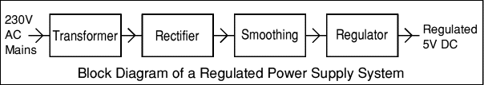

### **4.1.2 Transformer:**

### 

### transformer symbol

**Fig 4.1.1 Transformer.**

Transformers convert AC electricity from one voltage to another with little loss of power. Transformers work only with AC and this is one of the reasons why mains electricity is AC.Step-up transformers increase voltage, step-down transformers reduce voltage. Most power supplies use a step-down transformer to reduce the dangerously high mains voltage (230V in UK) to a safer low voltage.

The input coil is called the primary and the output coil is called the secondary. There is no electrical connection between the two coils; instead they are linked by an alternating magnetic field created in the soft-iron core of the transformer. The two lines in the middle of the circuit symbol represent the core.

### Transformers waste very little power so the power out is (almost) equal to the power in. Note that as voltage is stepped down current is stepped up.

The ratio of the number of turns on each coil, called the turn’s ratio, determines the ratio of the voltages. A step-down transformer has a large number of turns on its primary (input) coil which is connected to the high voltage mains supply, and a small number of turns on its secondary (output) coil to give a low output voltage.

Turns ratio=Vp/Vs=Nn/Ns and Power out=Power in

Vs*Is=Vp * Ip

|  |  |  |
| --- | --- | --- |
| Vp = primary (input) voltage Np = number of turns on primary coil Ip  = primary (input) current |  | Vs = secondary (output) voltage Ns = number of turns on secondary coil Is  = secondary (output) current |

### AC power supply, transformer only

**Fig 4.1.2 Transformer Characteristics.**

### The low voltage AC output is suitable for lamps, heaters and special AC motors. It is not suitable for electronic circuits unless they include a rectifier and a smoothing capacitor**.**

### **4.2 Rectifier:**

### There are several ways of connecting diodes to make a rectifier to convert AC toDC. The [bridge rectifier](http://www.kpsec.freeuk.com/powersup.htm#bridgerectifier)is the mostimportant and it produces full-wave varying DC. A full-wave rectifier can also be made from justtwo diodes if a centre-tap transformer is used, but this method is rarely used now that diodes arecheaper. A [single diode](http://www.kpsec.freeuk.com/powersup.htm#singlediode) can be used as arectifier but it only uses the positive (+) parts of the AC wave to produce half-wave varying DC.

### DC power supply, transformer + rectifier

**Fig 4.2Rectifier Circuit.**

The varying DC output is suitable for lamps, heaters and standard motors. It is not suitable for electronic circuits unless they include a smoothing capacitor.

### **4.2.1 Bridge rectifier:**

### A bridge rectifier can be made using four individual diodes, but it is also available in special packages containing the four diodes required. It is called a full-wave rectifier because it uses the entire AC wave (both positive and negative sections). 1.4V is used up in the bridge rectifier because each diode uses 0.7V when conducting and there are always two diodes conducting, as shown in the diagram below. Bridge rectifiers are ratedby the maximum current they can pass and the maximum reverse voltage they can withstand (this must be at least three times the supply [RMS](http://www.kpsec.freeuk.com/acdc.htm#rms) voltage so the rectifier can withstand the peak voltages). Please see the [Diodes](http://www.kpsec.freeuk.com/components/diode.htm#bridge) page for more details, including pictures of ridge rectifiers.

### **Operation of a Bridge Rectifier**

**Fig 4.2.1 Bridge Rectifier Circuit.**

Alternate pairs of diodes conduct, changing over the connections so the alternating directions of AC are converted to the one direction of DC.

### **Output: full-wave varying DC: (using the entire AC wave):**

### Full-wave Varying DC

**Fig 4.2.2 Bridge Rectifier Output Characteristics.**

#### **4.2.2 Single diode rectifier:**

A single diode can be used as a rectifier but this produces **half-wave** varying DC which has gaps when the AC is negative. It is hard to smooth this sufficiently well to supply electronic circuits unless they require a very small current so the smoothing capacitor does not significantly discharge during the gaps. Please see the [Diodes](http://www.kpsec.freeuk.com/components/diode.htm#rectifier) page for some examples of rectifier diodes.

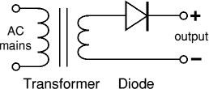

### **Fig 4.2.3Single Diode.**

### Output: half-wave varying DC (using only half the AC wave):

### 

### Half-wave Varying DC

### **Fig 4.2.4 Single Diode Output Characteristics.**

### **4.2.3 Smoothing**

### Smoothing is performed by a large value electrolytic capacitor connected across the DC supply to act as a reservoir, supplying current to the output when the varying DC voltage from the rectifier is falling. The diagram shows the unsmoothed varying DC (dotted line) and the smoothed DC (solid line). The capacitor charges quickly near the peak of the varying DC, and then discharges as it supplies current to the output.

### 

### Smoothing

**Fig 4.2.5Smoothing Circuit & Output Characteristics.**

### Note that smoothing significantly increases the average DC voltage to almost the peak value (1.4 × [RMS](http://www.kpsec.freeuk.com/acdc.htm#rms) value). For example 6V RMS AC is rectified to full wave DC of about 4.6V RMS (1.4V is lost in the bridge rectifier), with smoothing this increases to almost the peak value giving 1.4 × 4.6 = 6.4V smooth DC.

### Smoothing is not perfect due to the capacitor voltage falling a little as it discharges, giving a small ripple voltage. For many circuits a ripple which is 10% of the supply voltage is satisfactory and the equation below gives the required value for the smoothing capacitor. A larger capacitor will give fewer ripples. The capacitor value must be doubled when smoothing half-wave DC.

### Smoothing Capacitor for 10% ripple, C=5*10/vs.*f

### C = smoothing capacitance in farads (F)

### Io = output current from the supply in amps (A)

### Vs = supply voltage in volts (V), this is the peak value of the unsmoothed DC

### f    = frequency of the AC supply in hertz (Hz), 50Hz in the UK.

### Smooth DC power supply, transformer + rectifier + smoothing

**Fig 4.2.6Smoothing Circuit Connection.**

The smooth DC output has a small ripple. It is suitable for most electronic circuits.

### **4.2.4 Regulator**

### Voltage regulator ICs are available with fixed (typically 5, 12 and 15V) or variable output voltages. They are also rated by the maximum current they can pass. Negative voltage regulators are available, mainly for use in dual supplies. Most regulators include some automatic protection from excessive current ('overload protection') and overheating ('thermal protection').

The LM78XX series of three terminal regulators is available with several fixed output voltages making them useful in a wide range of applications. One of these is local on card regulation, eliminating the distribution problems associated with single point regulation. The voltages available allow these regulators to be used in logic systems, instrumentation, HiFi, and other solid state electronic equipment. Although designed primarily as fixed voltage regulators these devices can be used with external components to obtain adjustable voltages and current.

### Many of the fixed voltage regulator ICs has 3 leads and look like power transistors, such as the 7805 +5V 1A regulator shown on the right. They include a hole for attaching a [heat sink](http://www.kpsec.freeuk.com/components/heatsink.htm) if necessary.

1. Positive regulator
   1. input pin
   2. ground pin
   3. output pin

It regulates the positive voltage

1. Negative regulator
   1. ground pin
   2. input pin
   3. output pin

It regulate the negative voltage

### Voltage regulator

**Fig 4.2.7Regulator.**

### Regulated DC power supply, transformer + rectifier + smoothing + regulator

**Fig 4.2.8AC to DC Converter Circuit.**

The regulated DC output is very smooth with no ripple. It is suitable for all electronic circuits.

## **4.3 Vibration Sensor**

The vibration sensor is also called a [piezoelectric sensor](https://www.elprocus.com/what-is-a-piezoelectric-sensor-circuit-specifications-and-applications/). These sensors are flexible devices which are used for measuring various processes. This sensor uses the [piezoelectric effects](https://www.elprocus.com/what-is-the-piezoelectric-effect-working-and-its-applications/) while measuring the changes within acceleration, pressure, temperature, force otherwise strain by changing to an electrical charge. This sensor is also used for deciding fragrances within the air by immediately measuring capacitance as well as quality.

### **4.3.1 Vibration Sensor Working Principle**

The working principle of vibration sensor is [a sensor](https://www.elprocus.com/what-is-a-biosensor-types-of-biosensors-and-applications/) which operates based on different optical otherwise mechanical principles for detecting observed system vibrations.

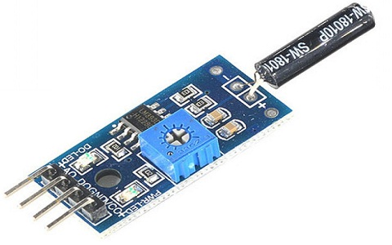

**Fig 4.3.1 vibration-sensor-module**

The sensitivity of these sensors normally ranges from 10 mV/g to 100 mV/g, and there are lower and higher sensitivities are also accessible. The sensitivity of the sensor can be selected based on the application. So it is essential to know the levels of vibration amplitude range to which the sensor will be exposed throughout measurements.

Sensors used to measure **vibration** come in three basic types: displacement, velocity, and acceleration.[Displacement sensors](https://instrumentationtools.com/contact-vibration-measurement/) measure changes in distance between a machine’s rotating element and its stationary housing (frame). Displacement sensors come in the form of a probe that threads into a hole drilled and tapped in the machine’s frame, just above the surface of a rotating shaft.Velocity and acceleration sensors, by contrast, measure the velocity or acceleration of whatever element the sensor is attached to, which is usually some external part of the machine frame.

## **4.3.2 Vibration sensors**

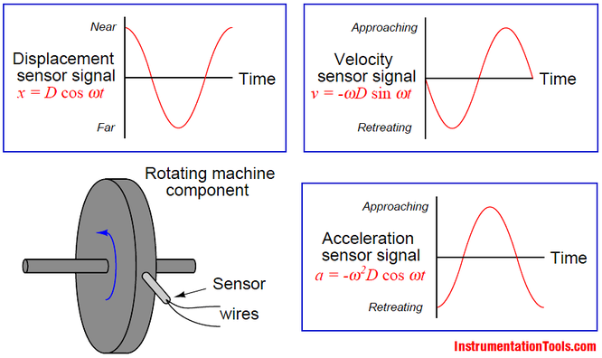

A design of [displacement sensor](https://instrumentationtools.com/non-contact-vibration-measurement/) manufactured by the Bently-Nevada corporation uses electromagnetic eddy current technology to sense the distance between the probe tip and the rotating machine shaft.

The sensor itself is an encapsulated coil of wire, energized with high-frequency alternating current (AC).

The magnetic field produced by the coil induces eddy currents in the metal shaft of the machine, as though the metal piece were a short-circuited secondary coil of a transformer (with the probe’s coil as the transformer primary winding).

The closer the shaft moves toward the sensor tip, the tighter the magnetic coupling between the shaft and the sensor coil, and the stronger the eddy currents.The high-frequency oscillator circuit providing the sensor coil’s excitation signal becomes loaded by the induced eddy currents.Therefore, the oscillator’s load becomes a direct indication of how close the probe tip is to the metal shaft. This is not unlike the operation of a metal detector: measuring the proximity of a wire coil to any metal object by the degree of loading caused by eddy current induction.In the Bently-Nevada design, the oscillator circuit providing sensor coil excitation is called a proximitor.The proximitor module is powered by an external DC power source, and drives the sensor coil through a coaxial cable.Proximity to the metal shaft is represented by a DC voltage output from the proximitor module, with 200 millivolts per mil (1 mil = 1 /1000 inch) of motion being the standard calibration.

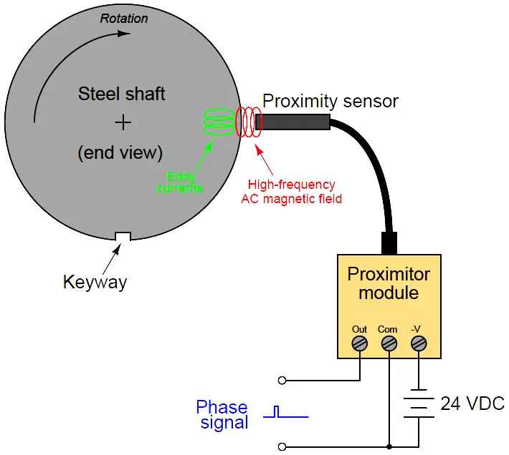

**Fig 4.4 proximity sensor**

Since the [proximitor’s](https://instrumentationtools.com/bently-nevada-vibration-probes-functional-testing/) output voltage is a direct representation of distance between the probe’s tip and the shaft’s surface, a “quiet” signal (no vibration) will be a pure DC voltage.

The probe is adjusted by a technician such that this quiescent voltage will lie between the proximitor’s output voltage range limits.

Any vibration of the shaft will cause the proximitor’s output voltage to vary in precise step. A shaft vibration of 28.67 Hz, for instance, will cause the proximitor output signal to be a 28.67 Hz waveform superimposed on the DC “bias” voltage set by the initial probe/shaft gap.

## **4.5 ACCELEROMETER SENSOR**

The rate of change of velocity of the body with respect to time is called acceleration. According to relative theory, depending upon the relative object taken to measure acceleration, there are two types of acceleration. The proper acceleration, which is the physical acceleration of the body relative to inertia or the observer who is at rest relative to the object being measured.

The coordinate acceleration depends upon the choice of coordinate system and choice of observers. This is not equal to proper acceleration. Accelerometer sensor is the electromechanical device used to measure the proper acceleration of the object.

### **4.5.1 Working Principle**

The basic underlying working principle of an accelerometer is such as a dumped mass on a spring. When acceleration is experienced by this device, the mass gets displaced till the spring can easily move the mass, with the same rate equal to the acceleration it sensed. Then this displacement value is used to measure the give the acceleration.

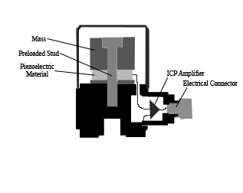

**Fig 4.5.1 PiezoAccelerometer-sensor**

Accelerometers are available as digital devices and analog devices. Accelerometers are designed using different methods. [Piezoelectric](https://www.elprocus.com/what-is-a-piezoelectric-sensor-circuit-specifications-and-applications/), piezoresistive and capacitive components are generally used to convert the mechanical motion caused in accelerometer into an electrical signal.

Piezoelectric accelerometers are made up of single crystals. These use the piezoelectric effect to measure the acceleration. When applied to stress, these crystals generate a voltage which is interpreted to determine the velocity and orientation.

Capacitive accelerometers use a silicon micro-machined element. Here capacitance is generated when acceleration is sensed and this capacitance is translated into a voltage to measure the velocity values.

Modern accelerometers are the smallest [MEMS](https://www.elprocus.com/understanding-fabrication-mems/), consisting of a cantilever beam with proof mass. Accelerometers are available as two-dimensional and three-dimensional forms to measure velocity along with orientation. When the upper-frequency range, high-temperature range, and low packaged weight are required, piezoelectric accelerometers are the best choice.

## Applications

**4.5.2 The Applications of Accelerometer sensor are as follows**

* For inertial navigation systems, highly sensitive accelerometers are used.
* To detect and monitor vibrations in rotating machinery.
* To display images in an upright position on screens of digital cameras.
* For flight stabilization in drones.
* Accelerometers are used to sense orientation, coordinate acceleration, vibration, shock.
* Used to detect the position of the device in laptops and mobiles.
* High-frequency recording of biaxial and triaxial acceleration in biological applications for discrimination of behavioral patterns of animals.
* Machinery health monitoring.
* To detect faults in rotator machines.
* These are also used for building and structural monitoring to measure the motion and vibration of the structure when exposed to dynamic loads.
* To measure the depth of CPR chest compressions.
* Navigation systems make use of accelerometer sensors for knowing the direction.
* Remote sensing devices also use accelerometers to monitor active volcanoes.

## **4.6 IOT (ESP 8266 -12E NODE MCU ) Module**

The development board equips the ESP-12E module containing ESP8266 chip having **TensilicaXtensa® 32-bit LX106 RISC microprocessor** which operates at **80 to 160 MHz** adjustable clock frequency and supports **RTOS**.

**4.6.1 ESP-12E Chip**

* TensilicaXtensa® 32-bit LX106
* 80 to 160 MHz Clock Freq.
* 128kB internal RAM
* 4MB external flash
* 802.11b/g/n Wi-Fi transceiver

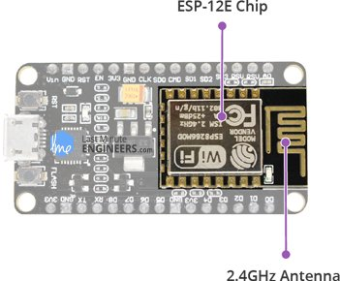

**Fig 4.6.1 ESP-12E CHIP**

There’s also **128 KB RAM and 4MB of Flash memory** (for program and data storage) just enough to cope with the large strings that make up web pages, JSON/XML data, and everything we throw at IoT devices nowadays.

The ESP8266 Integrates **802.11b/g/n HT40 Wi-Fi transceiver**, so it can not only connect to a WiFi network and interact with the Internet, but it can also set up a network of its own, allowing other devices to connect directly to it. This makes the ESP8266 NodeMCU even more versatile.

## **4.6.1.1Power Requirement**

As the operating voltage range of ESP8266 is **3V to 3.6V**, the board comes with a LDO voltage regulator to keep the voltage steady at 3.3V. It can reliably supply up to 600mA, which should be more than enough when ESP8266 pulls as much as **80mA during RF transmissions**. The output of the regulator is also broken out to one of the sides of the board and labeled as 3V3. This pin can be used to supply power to external components.

**4.6.1.2 POWER REQUIREMENT**

* Operating Voltage: 2.5V to 3.6V
* On-board 3.3V 600mA regulator
* 80mA Operating Current
* 20 µA during Sleep Mode

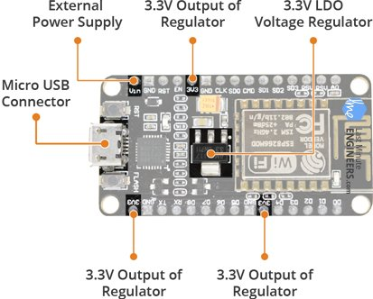

**FIG 4.6.1.2 POWER REQUIREMENT**

**Power to the ESP8266 NodeMCU**is supplied via the **on-boardMicroB USBconnector**. Alternatively, if you have a regulated 5V voltage source, the**VIN pin** can be used to directly supply the ESP8266 and its peripherals.

Warning:

The ESP8266 requires a 3.3V power supply and 3.3V logic levels for communication. The GPIO pins are not 5V-tolerant! If you want to interface the board with 5V (or higher) components, you’ll need to do some level shifting.

## **4.6.1.2 Peripherals and I/O**

The ESP8266 NodeMCU has total **17 GPIO pins** broken out to the pin headers on both sides of the development board. These pins can be assigned to all sorts of peripheral duties, including:

* **ADC channel** – A 10-bit ADC channel.
* **UART interface** – UART interface is used to load code serially.
* **PWM outputs** – PWM pins for dimming LEDs or controlling motors.
* **SPI, I2C & I2S interface** – SPI and I2C interface to hook up all sorts of sensors and peripherals.
* **I2S interface** – I2S interface if you want to add sound to your project.

**4.6.2 Multiplexed I/Os**

* 1 ADC channels
* 2 UART interfaces
* 4 PWM outputs
* SPI, I2C & I2S interface

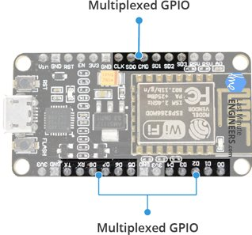

**FIG 4.6.2 MULTIPLEXED I/Os**

Thanks to the ESP8266’s **pin multiplexing feature** (Multiple peripherals multiplexed on a single GPIO pin). Meaning a single GPIO pin can act as PWM/UART/SPI.

## **4.6.3 On-board Switches & LED Indicator**

The ESP8266 NodeMCU features two buttons. One marked as **RST** located on the top left corner is the Reset button, used of course to reset the ESP8266 chip. The other **FLASH** button on the bottom left corner is the download button used while upgrading firmware.

**4.6.4 Switches & Indicators**

* RST – Reset the ESP8266 chip
* FLASH – Download new programs
* Blue LED – User Programmable

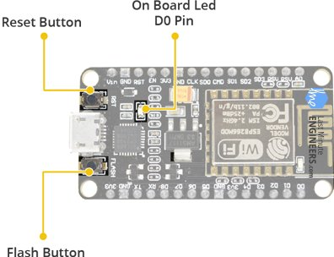

**FIG 4.6.4 SWITCHES AND INDICATORS**

The board also has a**LED indicator** which is user programmable and is connected to the D0 pin of the board.

## **4.6.5 Serial Communication**

The board includes CP2102 USB-to-UART Bridge Controller from [Silicon Labs](http://www.silabs.com/), which converts USB signal to serial and allows your computer to program and communicate with the ESP8266 chip.

**4.6.5.1 Serial Communication**

* CP2102 USB-to-UART converter
* 4.5 Mbps communication speed
* Flow Control support

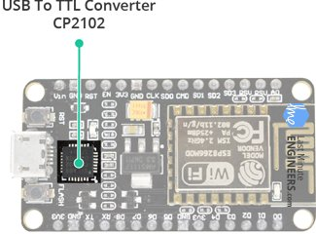

**FIG 4.6.5.1 SERIAL COMUNICATION**

If you have an older version of CP2102 driver installed on your PC, we recommend upgrading now.

[**CP2102 Driver**](https://www.silabs.com/products/development-tools/software/usb-to-uart-bridge-vcp-drivers)

## **4.7 ESP8266 NodeMCU Pinout**

The ESP8266 NodeMCU has total 30 pins that interface it to the outside world. The connections are as follows:

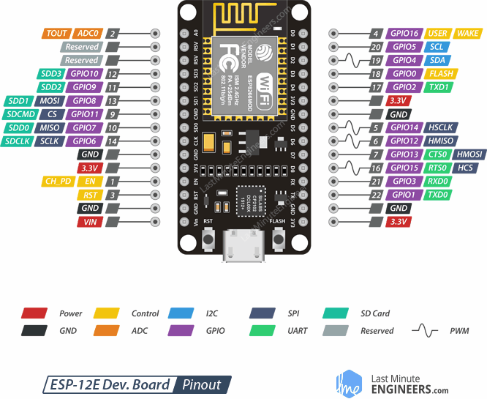

**FIG 4.7 ESP8266 NODEMCU PINOUT**

For the sake of simplicity, we will make groups of pins with similar functionalities.

**4.7.1 Power Pins**

There are four power pins viz. one VIN pin & three 3.3V pins. The VIN pin can be used to directly supply the ESP8266 and its peripherals, if you have a regulated 5V voltage source. The 3.3V pins are the output of an on-board voltage regulator. These pins can be used to supply power to external components.

4.7.2 GND

 is a ground pin of ESP8266 NodeMCU development board.

**4.7.3 I2C Pins**

are used to hook up all sorts of I2C sensors and peripherals in your project. Both I2C Master and I2C Slave are supported. I2C interface functionality can be realized programmatically, and the clock frequency is 100 kHz at a maximum. It should be noted that I2C clock frequency should be higher than the slowest clock frequency of the slave device.

**4,7,4 GPIO Pins**

ESP8266 NodeMCU has 17 GPIO pins which can be assigned to various functions such as I2C, I2S, UART, PWM, IR Remote Control, LED Light and Button programmatically. Each digital enabled GPIO can be configured to internal pull-up or pull-down, or set to high impedance. When configured as an input, it can also be set to edge-trigger or level-trigger to generate CPU interrupts.

**4.7.5 ADC Channel**

TheNodeMCU is embedded with a 10-bit precision SAR ADC. The two functions can be implemented using ADC viz. Testing power supply voltage of VDD3P3 pin and testing input voltage of TOUT pin. However, they cannot be implemented at the same time.

**4.7.6 UART Pins**

ESP8266 NodeMCU has 2 UART interfaces, i.e. UART0 and UART1, which provide asynchronous communication (RS232 and RS485), and can communicate at up to 4.5 Mbps. UART0 (TXD0, RXD0, RST0 & CTS0 pins) can be used for communication. It supports fluid control. However, UART1 (TXD1 pin) features only data transmit signal so, it is usually used for printing log.

**4.7.7 SPI Pins**

ESP8266 features two SPIs (SPI and HSPI) in slave and master modes. These SPIs also support the following general-purpose SPI features:

* 4 timing modes of the SPI format transfer
* Up to 80 MHz and the divided clocks of 80 MHz
* Up to 64-Byte FIFO

**4.7.8 SDIO Pins**

 ESP8266 features Secure Digital Input/Output Interface (SDIO) which is used to directly interface SD cards. 4-bit 25 MHz SDIO v1.1 and 4-bit 50 MHz SDIO v2.0 are supported.

**4.7.9 PWM Pins**

The board has 4 channels of Pulse Width Modulation (PWM). The PWM output can be implemented programmatically and used for driving digital motors and LEDs. PWM frequency range is adjustable from 1000 μs to 10000 μs, i.e., between 100 Hz and 1 kHz.

**4.7.10 Control Pins**

 are used to control ESP8266. These pins include Chip Enable pin (EN), Reset pin (RST) and WAKE pin.

* EN pin – The ESP8266 chip is enabled when EN pin is pulled HIGH. When pulled LOW the chip works at minimum power.
* RST pin – RST pin is used to reset the ESP8266 chip.
* WAKE pin – Wake pin is used to wake the chip from deep-sleep.

**4.8 BUZZER**

An audio signaling device like a beeper or buzzer may be electromechanical or [piezoelectric](https://www.elprocus.com/what-is-a-piezoelectric-material-working/) or mechanical type. The main function of this is to convert the signal from audio to sound. Generally, it is powered through DC voltage and used in timers, alarm devices, printers, alarms, computers, etc. Based on the various designs, it can generate different sounds like alarm, music, bell & siren.

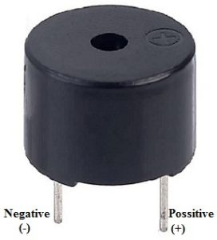

**FIG 4.8 Buzzer Pin Configuration**

The **pin configuration of the buzzer** is shown below. It includes two pins namely positive and negative. The positive terminal of this is represented with the ‘+’ symbol or a longer terminal. This terminal is powered through 6Volts whereas the negative terminal is represented with the ‘-‘symbol or short terminal and it is connected to the GND terminal.

### **4.8.1 History**

The history of an electromechanical buzzer and piezoelectric is discussed below.

#### **4.8.2 Electromechanical**

This buzzer was launched in the year 1831 by an American Scientist namely Joseph Henry but, this was used in doorbells until they were eliminated in 1930 in support of musical bells, which had a smooth tone.

#### **4.8.3 Piezoelectric**

These buzzers were invented by manufacturers of Japanese & fixed into a broad range of devices during the period of 1970s – 1980s. So, this development primarily came due to cooperative efforts through the manufacturing companies of Japanese. In the year 1951, they recognized the Application Research Committee of Barium Titanate that allows the corporations to be cooperative competitively & bring about numerous piezoelectric creations.

### **4.8.4 Specifications**

The **specifications of the buzzer** include the following.

* Color is black
* The frequency range is 3,300Hz
* Operating Temperature ranges from – 20° C to +60°C
* Operating voltage ranges from 3V to 24V DC
* The sound pressure level is 85dBA or 10cm
* The supply current is below 15Ma

### **4.8.5 Types of Buzzer**

A buzzer is available in different types which include the following.

* Piezoelectric
* Electromagnetic
* Mechanical
* Electromechanical
* Magnetic

#### **4.8.5.1 Piezoelectric**

As the name suggests, the piezoelectric type uses the piezoelectric ceramic’s piezoelectric effect & pulse current to make the metal plate vibrate & generate sound. This kind of buzzer is made with a resonance box, multi resonator, piezoelectric plate, housing, impedance matcher, etc. Some of the buzzers are also designed with [LEDs](https://www.elprocus.com/explain-different-types-leds-working-applications-engineering-students/).

The multi resonator of this mainly includes ICs and transistors. Once the supply is given to this resonator, it will oscillate and generates an audio signal with 1.5 to 2.kHz. The impedance matcher will force the piezoelectric plate to produce sound.

#### **4.8.5.2 Electromagnetic**

This type of buzzer is made with a magnet, solenoid coil, oscillator, housing, vibration diaphragm, and magnet. Once the [power supply](https://www.elprocus.com/regulated-power-supply-circuit-working-applications/) is given, the oscillator which produces the audio signal current will supply throughout the solenoid coil to generate a magnetic field.

Sometimes, the vibration diaphragm will vibrate & generates sound under the magnet & solenoid coil interaction. The frequency range of this ranges from 2 kHz to 4kHz.

#### **4.8.5.3 Mechanical**

These types of buzzers are subtypes of electromagnetic, so the [components](https://www.elprocus.com/basic-components-used-electronics-electrical/) used in this type are also similar. But the main difference is that the vibrating buzzer is placed on the outside instead of the inside.

#### **4.8.5.4 Electromechanical**

The designing of these types of buzzers can be done with a bare metal disc & an electromagnet. The working principle of this is similar to magnetic and electromagnetic. It generates sound throughout the disc movement & magnetism.

#### **4.8.5.5 Magnetic**

Like a piezo type, magnetic is also used to generate a sound but they are different due to core functionality. The magnetic type is more fixed as compared to the piezo type because they work through a magnetic field.

Magnetic buzzers utilize an electric charge instead of depending on piezo materials to generate a magnetic field, after that it permits another element of the buzzer to vibrate generate,sound.  
The applications of magnetic buzzers are similar to the piezo type in household devices, alarms such as watches, clocks & keyboards.

**4.9 Solar panel**

A solar panel is a set of solar photovoltaic modules electrically connected and mounted on a supporting structure. A photovoltaic module is a packaged, connected assembly of solar cells. The solar panel can be used as a component of a larger photovoltaic system to generate and supply electricity in commercial and residential applications. A photovoltaic system typically includes a panel or an array of solar modules, an inverter, and sometimes a battery and/or solar tracker and interconnection wiring. Photovoltaic cells or panels are only one way of generating electricity from solar energy. They are not the most efficient, but they are the most convents to use on a small to medium scale. PV cells are made of silicon, similar to that used in computer "chips". While silicon itself is a very abundant mineral, the manufacture of solar cells (as with computer chips) has to be in a very clean environment. This causes production costs to be high. A PV cell is constructed from two

types of silicon, which when hit by solar energy, produce a voltage difference across them, and, if connected to an electrical circuit, a current will flow. A number of photovoltaic cells will be connected together in a "Module", and usually encapsulated in glass held a frame which can then be mounted as required. The cells in a module will be wired in series or parallel to produce a specified voltage. What may be referred to as a 12 volt panel may produce around 16 volts in full sun to charge to 12 volt battery.

Here we use Energia company solar panel. The mechanical characteristics made from high efficiency crystalline silicon solar cells. Cells encapsulated in low iron, high transmission, toughened glass using UV stable ethylene vinyl acetate (EVA) sheets. Premium quality back sheet protect the module from environmental conditions. Laminate framed with strong anodized aluminum profile with fitted junction box.

Specification of the solar panel:

1. Material : Silicon

2. Wattage : 10W

3. Type : Polycrystalline

4. No of Cells : 64

5. Output Voltage : 21.5V

6. Short circuit current: 0.65A

7.voltage at maximum power: 17.5 V

8. Current at max. Power: 0.58 A

9. Tollerance : 5%

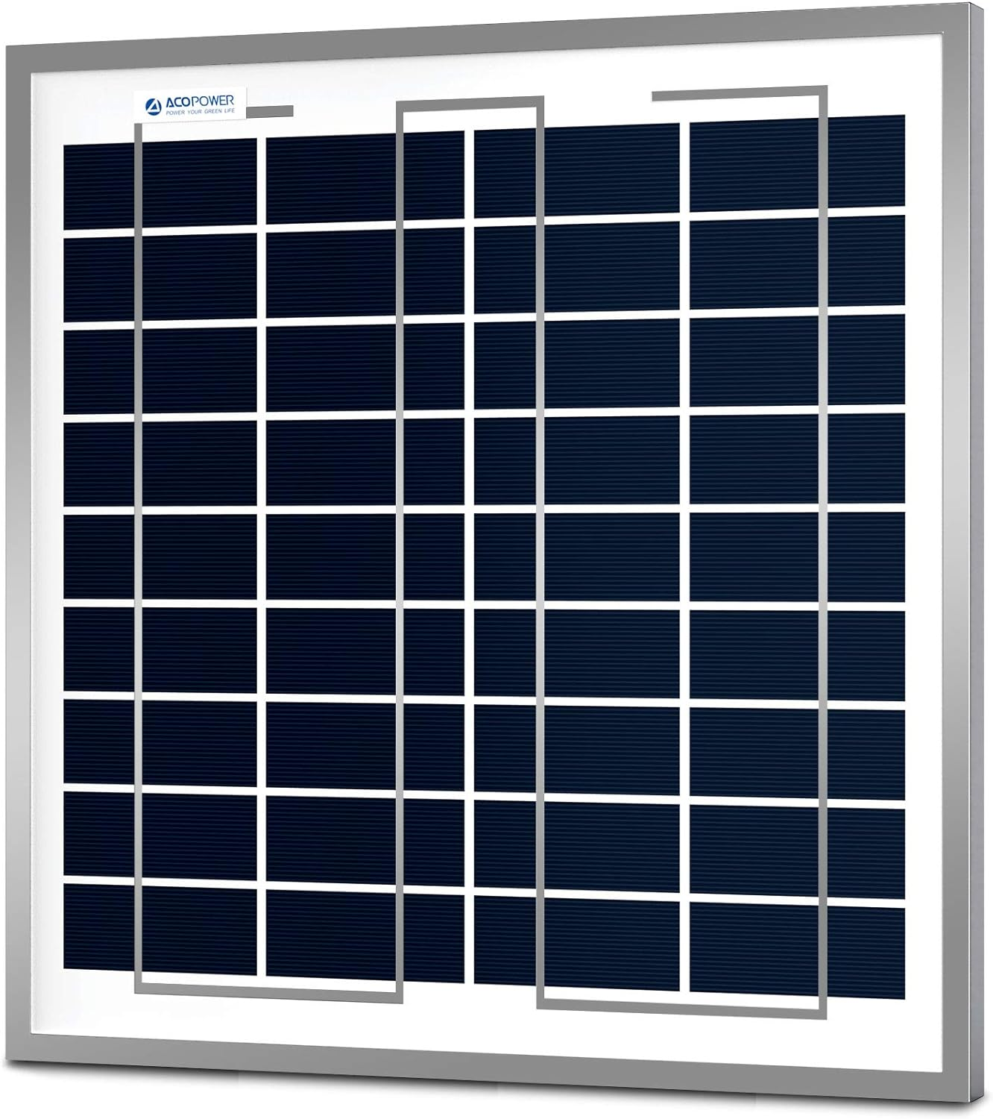

**FIG 4.9 solar panel**

**4.10 Dc motor**

Although motor gives 60 RPM at 12V but motor runs smoothly from 4V to 12V and gives wide range of RPM, and torque, 60RPM Centre Shaft Economy Series DC Motor is high quality low cost DC geared motor.

**Specifications of Dc motor:**

* 1. DC supply: 4 to 12V
  2. RPM: 60 at 12V
  3. Total length: 46mm
  4. Motor diameter: 36mm
  5. Motor length: 25mm
  6. Brush type: Precious metal
  7. Gear head diameter: 37mm
  8. Gear head length: 21mm
  9. Output shaft: Centered
  10. Shaft diameter: 6mm
  11. Shaft length: 22mm
  12. Gear assembly: Spur
  13. Motor weight: 105gms

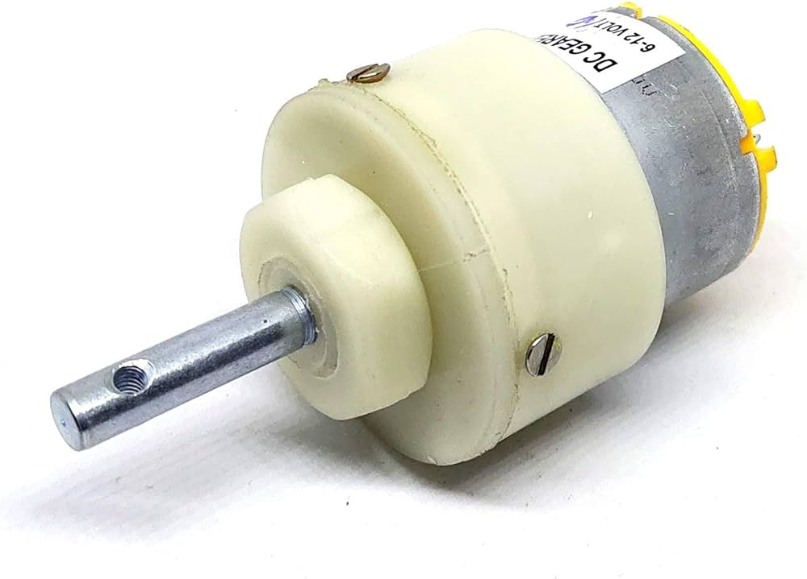

**FIG 4.10 solar panel**

**4.11 Boost Converter**

A boost converter (step-up converter) is a DC-to-DC power converter that steps up voltage (while stepping down current) from its input (supply) to its output (load). It is a class of switched-mode power supply (SMPS) containing at least two semiconductors (a diode and a transistor) and at least one energy storage element: a capacitor, inductor, or the two in combination. To reduce voltage ripple, filters made of capacitors (sometimes in combination with inductors) are normally added to such a converter's output (load-side filter) and input (supplyside filter).

Battery power systems often stack cells in series to achieve higher voltage. However, sufficient stacking of cells is not possible in many high voltage applications due to lack of space. Boost converters can increase the voltage and reduce the number of cells. Two battery-powered applications that use boost converters are used in hybrid electric vehicles (HEV) and lighting systems.

The NHW20 model Toyota Prius HEV uses a 500 V motor. Without a boost converter, the Prius would need nearly 417 cells to power the motor. However, a Prius actually uses only 168 cells[citation needed] and boosts the battery voltage from 202 V to 500 V. Boost converters also power devices at smaller scale applications, such as portable lighting systems. A white LED typically requires 3.3 V to emit light, and a boost converter can step up the voltage from a single 1.5 V alkaline cell to power the lamp.

An unregulated boost converter is used as the voltage increase mechanism in the circuit known as the 'Joule thief'. This circuit topology is used with low power battery applications, and is aimed at the ability of a boost converter to 'steal' the remaining energy in a battery. This energy would otherwise be wasted since the low voltage of a nearly depleted battery makes it unusable for a normal load. This energy would otherwise remain untapped because many applications do not allow enough current to flow through a load when voltage decreases. This voltage decrease occurs as batteries become depleted, and is a characteristic of the ubiquitous alkaline battery. Since the equation for power is R tends to be stable, power available to the load goes down significantly as voltage decreases.

`It is a dc to dc step-up converter. The simplest way to increase the voltage of a DC supply is to use a linear regulator (such as a 7805), but linear regulators waste energy as they operate by dissipating excess power as heat. Boost converters, on the other hand, can be remarkably efficient (95% or higher for integrated circuits). It utilizes a MOSFET switch (IRFP250N), a diode, inductor and a capacitor. Few resistors also are used in the circuit for the protection of the main components. When the MOSFET switch is ‘ON’ current rises Through inductor, capacitor and load. Inductor stores energy. When switch is ‘OFF’ the energy in the inductor circulates current through inductor, capacitor freewheeling diode and load. The output voltage will be greater than or equal to the input voltage.

Here we use an LM2596 DC-DC buck converter step-down power module with high-precision potentiometer for adjusting output voltage, capable of driving a load up to 3A with high efficiency.

The specification of the DC-DC boost converter are-

1. Module properties : non-isolated constant voltage module

2. Rectification : non-synchronous rectification

3. Input Voltage : 0V-35V

4. Output Current : 3A maximum

5. Output Voltage : 1.3V-30V

6. Conversion efficiency : 92% (maximum)

7. Switching frequency : 150KHz

8. Output ripple : 50mV (maximum) 20M-bandwidth

9. Load regulation : ± 0.5 %

10. Voltage regulation : ± 2.5%

11. Operating temperature : -40 °C to +85 °C

12. Size : 48x23x14 mm

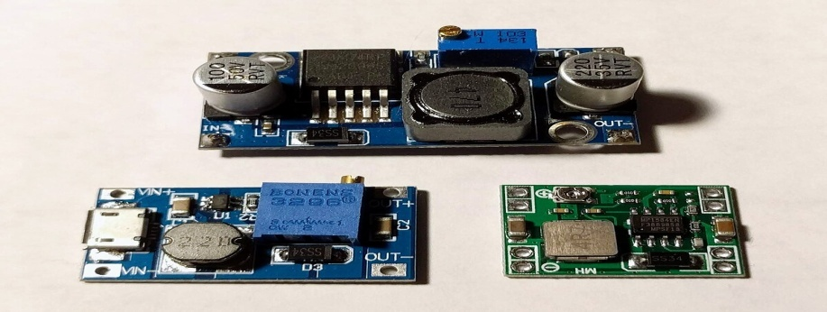

**FIG 4.11 DC to DC boost converter**

**4.12 Lead acid Battery**

The electrical energy produced by the system is need to be either utilized completely or stored. Complete utilization of all the energy produced by the system for all the time is not possible. So, it should be store rather than useless wasting it. Electrical batteries is the most relevant, low cost, maximum efficient storage of electrical energy in the form of chemical reaction. Hence, batteries are

preferred.The energy generated from the proposed project is need to be store. So, two batteries is needed. One is attached to wind turbine for which a 120AmpH battery will be required, which will be fair enough full fill the storage capacity for targeted value. The second battery is 80AmpH is preferred for storing solar energy. But, as per application storage and demand battery capacity can be variable.

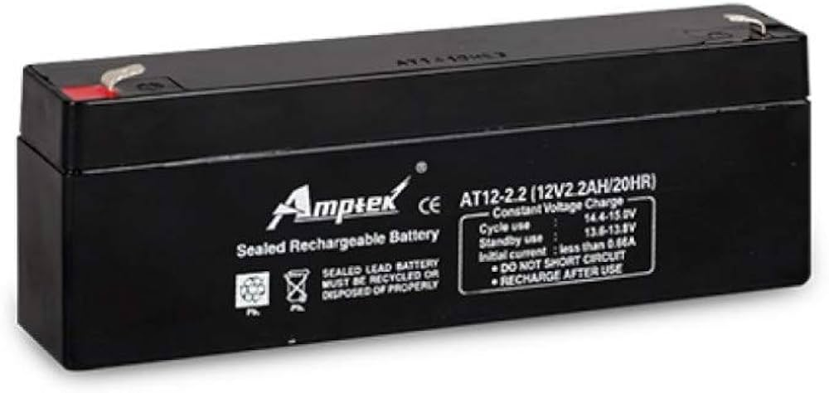

**FIG 4.12 lead acid battery**

**CHAPTER – 5**

**5.1 SOFTWARE DESCRIPTION**

In the getting started guide ([Windows](https://www.arduino.cc/en/Guide/Windows), [Mac OS X](https://www.arduino.cc/en/Guide/MacOSX), [Linux](http://www.arduino.cc/playground/Learning/Linux)), you uploaded a sketch that blinks an LED. In this tutorial, you'll learn how each part of that sketch works.

A sketch is the name that Arduino uses for a program. It's the unit of code that is uploaded to and run on an Arduino board.

**5.2 Arduino** is an open source, computer hardware and software company, project, and user community that designs and manufactures [microcontroller](https://en.wikipedia.org/wiki/Microcontroller) kits for building digital devices and interactive objects that can sense and control objects in the physical world. The project's products are distributed as [open-source hardware](https://en.wikipedia.org/wiki/Open-source_hardware) and [software](https://en.wikipedia.org/wiki/Open-source_software), which are licensed under the [GNU Lesser General Public License](https://en.wikipedia.org/wiki/GNU_Lesser_General_Public_License) (LGPL) or the GNU General Public License (GPL),[1] permitting the manufacture of Arduino boards and software distribution by anyone. Arduino boards are available commercially in preassembled form, or as do-it-yourself kits.

Arduino board designs use a variety of microprocessors and controllers. The boards are equipped with sets of digital and analog input/output(I/O) pins that may be interfaced to various expansion boards (*shields*) and other circuits. The boards feature serial communications interfaces, including Universal Serial Bus(USB) on some models, which are also used for loading programs from personal computers. The microcontrollers are typically programmed using a dialect of features from the programming languages C and C++ In addition to using traditional compiler toolchains, the Arduino project provides an integrated development environment (IDE) based on the Processing language project.

The Arduino project started in 2003 as a program for students at the Interaction Design Institute Ivrea in Ivrea. Italy,[2] aiming to provide a low-cost and easy way for novices and professionals to create devices that interact with their environment using sensors and actuators. Common examples of such devices intended for beginner hobbyists include simple robots, thermostats, and motion detectors.

### **Arduino**

Arduino is an open-source electronics platform based on easy-to-use hardware and software. Arduino boards are able to read inputs - light on a sensor, a finger on a button, or a Twitter message - and turn it into an output - activating a motor, turning on an LED, publishing something online. You can tell your board what to do by sending a set of instructions to the microcontroller on the board. To do so you use the Arduino programming language (based on Wiring), and the Arduino Software (IDE), based on Processing.

Over the years Arduino has been the brain of thousands of projects, from everyday objects to complex scientific instruments. A worldwide community of makers - students, hobbyists, artists, programmers, and professionals - has gathered around this open-source platform, their contributions have added up to an incredible amount of accessible knowledge that can be of great help to novices and experts alike.

Arduino was born at the Ivrea Interaction Design Institute as an easy tool for fast prototyping, aimed at students without a background in electronics and programming. As soon as it reached a wider community, the Arduino board started changing to adapt to new needs and challenges, differentiating its offer from simple 8-bit boards to products for IoT applications, wearable, 3D printing, and embedded environments. All Arduino boards are completely open-source, empowering users to build them independently and eventually adapt them to their particular needs. The software, too, is open-source, and it is growing through the contributions of users worldwide.

There are many other microcontrollers and microcontroller platforms available for physical computing. Parallax Basic Stamp, Netmedia's BX-24, Phidgets, MIT's Handyboard, and many others offer similar functionality. All of these tools take the messy details of microcontroller programming and wrap it up in an easy-to-use package. Arduino also simplifies the process of working with microcontrollers, but it offers some advantage for teachers, students, and interested amateurs over other systems:

* **Inexpensive** - Arduino boards are relatively inexpensive compared to other microcontroller platforms. The least expensive version of the Arduino module can be assembled by hand, and even the pre-assembled Arduino modules cost less than $50
* **Cross-platform** - The Arduino Software (IDE) runs on Windows, Macintosh OSX, and Linux operating systems. Most microcontroller systems are limited to Windows.
* **Simple, clear programming environment** - The Arduino Software (IDE) is easy-to-use for beginners, yet flexible enough for advanced users to take advantage of as well. For teachers, it's conveniently based on the Processing programming environment, so students learning to program in that environment will be familiar with how the Arduino IDE works.
* **Open source and extensible software** - The Arduino software is published as open source tools, available for extension by experienced programmers. The language can be expanded through C++ libraries, and people wanting to understand the technical details can make the leap from Arduino to the AVR C programming language on which it's based. Similarly, you can add AVR-C code directly into your Arduino programs if you want to.
* **Open source and extensible hardware** - The plans of the Arduino boards are published under a Creative Commons license, so experienced circuit designers can make their own version of the module, extending it and improving it. Even relatively inexperienced users can build the breadboard version of the module in order to understand how it works and save money.

### **5.2.1 Variables**

A variable is a place for storing a piece of data. It has a name, a type, and a value. For example, the line from the Blink sketch above declares a variable with the name ledPin, the type int, and an initial value of 13. It's being used to indicate which Arduino pin the LED is connected to. Every time the name ledPin appears in the code, its value will be retrieved. In this case, the person writing the program could have chosen not to bother creating the ledPin variable and instead have simply written 13 everywhere they needed to specify a pin number. The advantage of using a variable is that it's easier to move the LED to a different pin: you only need to edit the one line that assigns the initial value to the variable.

### **5.3 Functions**

A function (otherwise known as a procedure orsub-routine) is a named piece of code that can be used from elsewhere in a sketch. For example, here's the definition of the setup() function from the Blink example:

void **setup**()  
{  
   pinMode(ledPin, OUTPUT);         
}

The first line provides information about the function, like its name, "setup". The text before and after the name specify its return type and parameters: these will be explained later. The code between the { and } is called the body of the function: what the function does.

### **pinMode(), digitalWrite(), and delay()**

The pinMode() function configures a pin as either an input or an output. To use it, you pass it the number of the pin to configure and the constant INPUT or OUTPUT. When configured as an input, a pin can detect the state of a sensor like a pushbutton; As an output, it can drive an actuator like an LED.

The digitalWrite() functions outputs a value on a pin.

For example, the line:

digitalWrite(ledPin, HIGH);

The delay() causes the Arduino to wait for the specified number of milliseconds before continuing on to the next line. There are 1000 milliseconds in a second, so the line:

delay(1000);

### **5.3.1 setup() and loop()**

There are two special functions that are a part of every Arduino sketch: setup() and loop(). The setup() is called once, when the sketch starts. It's a good place to do setup tasks like setting pin modes or initializing libraries. The loop() function is called over and over and is heart of most sketches. You need to include both functions in your sketch, even if you don't need them for anything.

Everything between the /* and */ is ignored by the Arduino when it runs the sketch (the * at the start of each line is only there to make the comment look pretty, and isn't required). It's there for people reading the code: to explain what the program does, how it works, or why it's written the way it is. It's a good practice to comment your sketches, and to keep the comments up-to-date when you modify the code. This helps other people to learn from or modify your code.

**5.4 Project coding**

#define CAYENNE_PRINT Serial

#include <CayenneMQTTESP8266.h>

// WiFi network info.

char ssid[] ="project";

char wifiPassword[] ="123456789";

char red1;

//earthquake@gmail.com

//123456789

// Cayenne authentication info. This should be obtained from the Cayenne Dashboard.

char username[] = "8ab9a500-ea32-11ed-8485-5b7d3ef089d0";

char password[] = "ef72c68a4305186782b6169d5996e51080f45589";

char clientID[] = "9a4f5c30-ea32-11ed-9ab8-d511caccfe8c";

#define acc A0

#define vib D1

#define buz D2

int a=0,b=0,c=0,i=0;

void setup()

{

Cayenne.begin(username, password, clientID, ssid, wifiPassword);

pinMode(acc,INPUT);

pinMode(vib,INPUT);

pinMode(buz,OUTPUT);

Serial.begin(9600);

delay(200);

}

void loop()

{

Cayenne.loop();

digitalWrite(buz,LOW);

a=analogRead(acc);

c=digitalRead(vib);

delay(300);

Cayenne.virtualWrite(1,a);

delay(500);

Cayenne.virtualWrite(2,c);

delay(500);

Cayenne.virtualWrite(3,b);

delay(500);

if(c==1)

{

digitalWrite(buz,HIGH);

delay(5000);

digitalWrite(buz,LOW);

}

else

{

digitalWrite(buz,LOW);

delay(500);

}

if(a>=550)

{

i=i+1;

}

if(i==4)

{

digitalWrite(buz,HIGH);

b=1;

Cayenne.virtualWrite(3,b);

delay(1000);delay(1000);delay(1000);

delay(1000);delay(1000);

digitalWrite(buz,LOW);

i=0;

}

if(i<=2)

{

b=0;

Cayenne.virtualWrite(3,b);

delay(500);

}

}

**CHAPTER – 6**

**6 ADVANTAGES & APPLICATION**

**6.1 ADVANTAGES**

1. Real-time Detection: The LSS system provides real-time monitoring of ground vibrations, enabling early detection of earthquakes. This allows for timely response and action to mitigate potential damages.
2. Cost-effective: By utilizing low-cost IoT components, the LSS system offers a cost-effective alternative to traditional earthquake detection methods. It makes earthquake detection accessible for widespread deployment, including remote or underdeveloped areas.
3. Wide Deployment: The LSS system can be deployed in various locations due to its low-cost and wireless connectivity. This allows for a broader coverage of earthquake detection, enhancing overall preparedness and response.
4. Immediate Alerts: The system triggers an alarm through a buzzer as soon as the vibration levels exceed the predefined thresholds. This provides immediate alerts to people in the vicinity, allowing them to take necessary actions such as seeking shelter or evacuating.
5. Notifications to Authorities: The LSS system sends notifications to concerned authorities, including emergency services, rescue teams, and local governments. These notifications enable the authorities to initiate appropriate response measures promptly, such as deploying resources and coordinating rescue efforts.
6. Cloud-Based Analysis: The LSS system utilizes a cloud server, such as the Cayenne cloud server, for data analysis. This centralized approach allows for historical analysis and research, leading to improved earthquake prediction and response strategies.
7. The hybrid energy system will help to generate energy in earthquake proned areas
8. The energy will eco-friendly and reduce globalwarming and supply to the battery stations
9. Cost low compare to permenant windmill constructions.
10. Because they combine wind and solar energy, this systems deliver a more consistent power supply in the face of changing weather conditions. If it's cloudy, rainy, and windy one day, the wind turbines can compensate for the lagging solar panels. And on a sunny, calm day, the solar panels take over

**6.2 APPLICATION**

1. Public Safety: The LSS system can be deployed in public areas, including schools, hospitals, offices, and residential buildings, to ensure the safety of individuals during earthquakes. It provides early warnings and alerts to people, allowing them to take immediate actions to protect themselves.
2. Infrastructure Protection: The LSS system can be installed in critical infrastructure, such as bridges, dams, and power plants, to monitor ground vibrations and detect potential damage caused by earthquakes. This helps in timely maintenance and repair, ensuring the integrity and safety of infrastructure.
3. Disaster Management: The LSS system plays a crucial role in disaster management by providing real-time earthquake data to authorities. It aids in decision-making, resource allocation, and coordination of rescue and relief efforts.
4. Research and Development: The data collected by the LSS system, stored in the cloud server, can be utilized for research and development purposes. It enables the study of earthquake patterns, the development of improved prediction models, and the enhancement of response strategies to minimize the impact of earthquakes.
5. Early Warning Systems: The LSS system can be integrated into early warning systems to provide advance notice of earthquakes. By combining the LSS data with other seismic data sources, more accurate and comprehensive early warning systems can be developed.
6. Produce Renewable energy: the renewable energy is eco-friendly and solar and wind are good combination of produce high amount of energy
7. A wind-solar hybrid system is an alternative power generation system that pairs two great forces in green energy: photovoltaic (solar) panels and wind turbines. By harnessing the strengths of wind and solar power, this hybrid system maximizes energy production
8. When the sun shines or the wind blows, solar panels and wind turbines gather their energy to generate electricity, powering homes and businesses. And these renewable sources of electricity support peoples' lives without emitting the planet-heating gases that come from burning fossil fuels like coal, oil, and gas.

**CHAPTER – 7**

**7 RESULTS AND DISCUSSION**

he Life Saving System (LSS) proposed in this IoT-based approach to earthquake detection has the primary objective of detecting earthquakes as early as possible and notifying the concerned authorities and people to take appropriate actions. By constantly monitoring ground vibrations using the accelerometer and vibration sensors, the LSS aims to provide real-time detection and alerts.The LSS system operates by monitoring the ground vibrations continuously. The sensors, including the accelerometer and vibration sensors, detect even the slightest changes in the vibrations and send the data to the IoT module. The data collected by the sensors is then compared with predefined threshold limits within the IoT module.When the vibration levels detected by the sensors exceed the predefined thresholds, the IoT module triggers the buzzer to sound an alarm. This audible alarm helps alert people in the vicinity about the potential earthquake, allowing them to take immediate actions such as seeking shelter or moving to safer areas.

Simultaneously, the IoT module sends the earthquake data to the Cayenne cloud server through an internet connection. The cloud server receives and analyzes the data, comparing it against the predefined thresholds. Based on this analysis, the cloud server generates alerts to notify the concerned authorities, including emergency services, rescue teams, and local governments.

The alerts sent by the cloud server to the authorities ensure that timely response and necessary measures can be taken to prevent or reduce potential damages caused by earthquakes. These notifications provide crucial information to the relevant authorities, enabling them to initiate emergency protocols, allocate resources, and coordinate rescue efforts more effectively.The utilization of IoT technologies in the LSS system offers several advantages. Firstly, it enables real-time earthquake detection, allowing for prompt response and actions. Traditional methods relying on seismometers often suffer from delays, but with the LSS system, the alerts are generated as soon as the predefined thresholds are exceeded.Secondly, the LSS system is cost-effective and suitable for widespread deployment. Traditional seismometers can be expensive and require specialized installations. In contrast, the LSS system utilizes low-cost IoT components and wireless connectivity, making it accessible for deployment in various locations, including remote or underdeveloped areas.

Moreover, the LSS system provides centralized data storage and historical analysis through the Cayenne cloud server. This feature allows for the examination of past earthquake data, facilitating research and the development of improved prediction and response strategies in the future.

**7.1 CONCLUSION**

The proposed Life Saving System (LSS) offers a sensor-based approach to earthquake detection using iot technology. Its primary objective is to detect earthquakes as early as possible and provide timely alerts to concerned authorities and individuals to take appropriate actions and mitigate potential damages.By constantly monitoring ground vibrations using accelerometer and vibration sensors, the LSS system ensures real-time detection of even the slightest changes in the vibrations. The data collected by the sensors is processed within the IoT module and compared against predefined thresholds. When the vibration levels exceed these thresholds, the system triggers the buzzer to sound an alarm, alerting people in the vicinity of the potential earthquake.Simultaneously, the LSS system sends the earthquake data to the Cayenne cloud server through an internet connection. The cloud server analyzes the data and generates alerts based on the predefined thresholds. These alerts are crucial for notifying concerned authorities, including emergency services, rescue teams, and local governments.

The implementation of the LSS system provides several advantages over traditional earthquake detection methods. It offers real-time monitoring and detection, enabling prompt responses and actions to mitigate the impact of earthquakes. Moreover, the LSS system is cost-effective and suitable for widespread deployment due to its utilization of low-cost IoT components.the Life Saving System (LSS) proposed in this IoT-based approach to earthquake detection demonstrates the potential to enhance the timely detection of earthquakes and improve response mechanisms. By leveraging IoT technologies, the LSS system offers real-time monitoring, cost-effectiveness, and widespread deployment capabilities. Through early alerts and notifications, the LSS system can contribute to reducing the impact of earthquakes and saving lives by enabling timely actions by both authorities and individuals.Furthermore, the LSS system should be complemented with established emergency response protocols and public awareness campaigns to maximize its effectiveness. Educating the public about earthquake safety measures and providing clear instructions on how to respond to alerts is crucial for minimizing the loss of life and property during earthquakes. This system attached on movable vehicle. This movable vehicle had solar and wind energy generating system also attached. The movable vehicle is travelled in earthquake proned zones and generating energy in that areas if earthquake happen the earth quake detection kit alerted. The vehicle moved to the saferzones.

**CHAPTER – 8**

**REFERENCES**

1. Naito S., Azuma H., Senna S., Yoshizawa M., Nakamura H., Hao K.X., Fujiwara H., Hirayama Y., Yuki N., Yoshida M. Development and testing of a mobile application for recording and analyzing seismic data. *J. Disaster Res.*2013;**8**:990–1000. doi: 10.20965/jdr.2013.p0990.

2. Allen R.M., Gasparini P., Kamigaichi O., Bose M. The status of earthquake early warning around the world: An introductory overview. *Seismol. Res. Lett.*2009;**80**:682–693. doi: 10.1785/gssrl.80.5.682.

3. Nakamura Y. On the urgent earthquake detection and alarm system (UrEDAS); Proceedings of the 9th World Conference on Earthquake Engineering; Tokyo, Japan. 7–9 August 1988; pp. 673–678.

4. Allen R.M., Brown H., Hellweg M., Khainovski O., Lombard P., Neuhauser D. Real-time earthquake detection and hazard assessment by ElarmS across California. *Geophys. Res. Lett.*2009;**36** doi: 10.1029/2008GL036766.

5. Nakamura H., Horiuchi S., Wu C., Yamamoto S., Rydelek P.A. Evaluation of the real-time earthquake information system in Japan. *Geophys. Res. Lett.*2009;**36** doi: 10.1029/2008GL036470.

6. Hsiao N.C., Wu Y.M., Shin T.C., Zhao L., Teng T.L. Development of earthquake early warning system in Taiwan. *Geophys. Res. Lett.*2009;**36** doi: 10.1029/2008GL036596.

7. Satriano C., Elia L., Martino C., Lancieri M., Zollo A., Iannaccone G. PRESTo, the earthquake early warning system for southern Italy: Concepts, capabilities and future perspectives. *Soil Dyn. Earthq. Eng.*2011;**31**:137–153. doi: 10.1016/j.soildyn.2010.06.008.

8. Nakamura Y., Saita J., Sato T. On an earthquake early warning system (EEW) and its applications. *Soil Dyn. Earthq. Eng.*2011;**31**:127–136. doi: 10.1016/j.soildyn.2010.04.012.

9. Hoshiba M., Kamigaichi O., Saito M., Tsukada S.Y., Hamada N. Earthquake early warning starts nationwide in Japan. *EOS Trans. Am. Geophys. Union.*2008;**89**:73–74. doi: 10.1029/2008EO080001.

10. Wu Y.-M., Kanamori H. Development of an earthquake early warning system using real-time strong motion signals. *Sensors.*2008;**8**:1–9. doi: 10.3390/s8010001.

11. Erdik M., Fahjan Y., Ozel O., Alcik H., Mert A., Gul M. Istanbul earthquake rapid response and the early warning system. *Bull. Earthq. Eng.*2003;**1**:157–163. doi: 10.1023/A:1024813612271.

12. Gasparini P., Manfredi G., Zschau J. *Earthquake Early Warning Systems.* Springer; Berlin/Heidelberg, Germany: 2007.

13. Wurman G., Allen R.M., Lombard P. Toward earthquake early warning in northern California. *J. Geophys. Res. Solid Earth.*2007;**112** doi: 10.1029/2006JB004830.

14. Kamigaichi O., Saito M., Doi K., Matsumori T., TsukadaS.y., Takeda K., Shimoyama T., Nakamura K., Kiyomoto M., Watanabe Y. Earthquake early warning in Japan: Warning the general public and future prospects. *Seismol. Res. Lett.*2009;**80**:717–726. doi: 10.1785/gssrl.80.5.717.

15. Zollo A., Amoroso O., Lancieri M., Wu Y.-M., Kanamori H. A threshold-based earthquake early warning using dense accelerometer networks. *Geophys. J. Int.*2010;**183**:963–974. doi: 10.1111/j.1365-246X.2010.04765.x.

16. Böse M., Ionescu C., Wenzel F. Earthquake early warning for Bucharest, Romania: Novel and revised scaling relations. *Geophys. Res. Lett.*2007;**34** doi: 10.1029/2007GL029396.

17. Cochran E.S., Lawrence J.F., Christensen C., Jakka R.S. The quake-catcher network: Citizen science expanding seismic horizons. *Seismol. Res. Lett.*2009;**80**:26–30. doi: 10.1785/gssrl.80.1.26.

18. Clayton R., Heaton T., Chandy M., Krause A., Kohler M., Bunn J., Olson M., Faulkner M., Cheng M., Strand L. Community seismic network. *Ann. Geophys.*2011;**54**:738–747.

19. Luetgert J., Evans J., Hamilton J., Hutt C., Jensen E., Oppenheimer D. NetQuakes—A new approach to urban strong-motion seismology; Proceedings of the AGU Fall Meeting Abstracts; San Francisco, CA, USA. 14–18 December 2009

20. Reilly J., Dashti S., Ervasti M., Bray J.D., Glaser S.D., Bayen A.M. Mobile phones as seismologic sensors: Automating data extraction for the iShake system. *IEEE Trans. Autom. Sci. Eng.*2013;**10**:242–251. doi: 10.1109/TASE.2013.2245121.

21. Kong Q., Allen R.M., Schreier L., Kwon Y.-W. MyShake: A smartphone seismic network for earthquake early warning and beyond. *Sci. Adv.*2016;**2**:e1501055. doi: 10.1126/sciadv.1501055. 22. Kong Q., Kwony Y.-W., Schreierz L., Allen S., Allen R., Strauss J. Smartphone-based networks for earthquake detection; Proceedings of the 2015 15th International Conference on Innovations for Community Services (I4CS); Nuremberg, Germany. 8–10 July 2015; pp. 1–8.

23. Tan R., Xing G., Chen J., Song W.-Z., Huang R. Fusion-based volcanic earthquake detection and timing in wireless sensor networks. *ACM Trans. Sens. Netw.*2013;**9**:1–25. doi: 10.1145/2422966.2422974.

24. Kumar S., Vig R., Kapur P. Development of earthquake event detection technique based on STA/LTA algorithm for seismic alert system. *J. Geol. Soc. India.*2018;**92**:679–686. doi: 10.1007/s12594-018-1087-3.

25. Sharma B., Kumar A., Murthy V. Evaluation of seismic events detection algorithms. *J. Geol. Soc. India.*2010;**75**:533–538. doi: 10.1007/s12594-010-0042-8.

26. Liu C., Park J.-W., Spencer B., Jr., Moon D.-S., Fan J. Sensor fusion for structural tilt estimation using an acceleration-based tilt sensor and a gyroscope. *Smart Mater. Struct.*2017;**26**:105005. doi: 10.1088/1361-665X/aa84a0.

27. Hernández-Rojas D.L., Fernández-Caramés T.M., Fraga-Lamas P., Escudero C.J. Design and practical evaluation of a family of lightweight protocols for heterogeneous sensing through BLE beacons in IoT telemetry applications. *Sensors.*2018;**18**:57. doi: 10.3390/s18010057.

28. Tajinii H. A statistical method of determining the maximum response of a building structure during an earthquake; Proceedings of the 2nd World Conference on Earthquake Engineering; Tokio, Japan. 11–18 July 1960.

29. Kanai K. *Semi-Empirical Formula for the Seismic Characteristics of the Ground.* Volume 35. Bulletin of the Earthquake Research Institute, University of Tokyo; Tokyo, Japana: 1957. pp. 309–325.

30. Lin Y., Yong Y. Evolutionary kanai-tajimi earthquake models. *J. Eng. Mech.*1987;**113**:1119–1137. doi: 10.1061/(ASCE)0733-9399(1987)113:8(1119).

31. Alotta G., Di Paola M., Pirrotta A. Fractional Tajimi–Kanai model for simulating earthquake ground motion. *Bull. Earthq. Eng.*2014;**12**:2495–2506. doi: 10.1007/s10518-014-9615-z.

32. G.S. Kaloi, J. Wang, M.H. Baloch and S. Tahir, "Wind Energy Potential at Badin and Pasni Costal Line of Pakistan", International Journal of Renewable Energy Development, vol. 6, no. 2, 2017.

33. S.H. Memon, M. Kumar, A.H. Memon, Z.A. Memon and S.A. Soomro, "Total Harmonic Distortion (THD) Analysis of Grid Integrated Permanent Magnet Synchronous Generator (PMSG) With Full Scale Converter (FSC) Based Wind Farm", IJCSNS, vol. 18, no. 12, pp. 232, 2018.

34. S.H. Memon, P.H. Shaikh, Z.A. Memon and M.A. Mari, "Building Integrated Small Scale Standalone Solar PV-Wind Based Hybrid DC Microgrid Power System", International Conference on Sustainable Development in Civil Engineering, December 05–07, 2019

35. Pritesh P. Shirsath, Anant Pise and Ajit Shinde, "Solar-Wind Hybrid Energy Generation System", International Journal of Engineering Research and General Science, vol. 4, no. 2, 2016.

36. S.H. Memon, P.H. Shaikh, Z.A. Memon and M.A. Mari, "Building Integrated Small Scale Standalone Solar PV-Wind Based Hybrid DC Microgrid Power System", International Conference on Sustainable Development in Civil Engineering, December 05–07, 2019